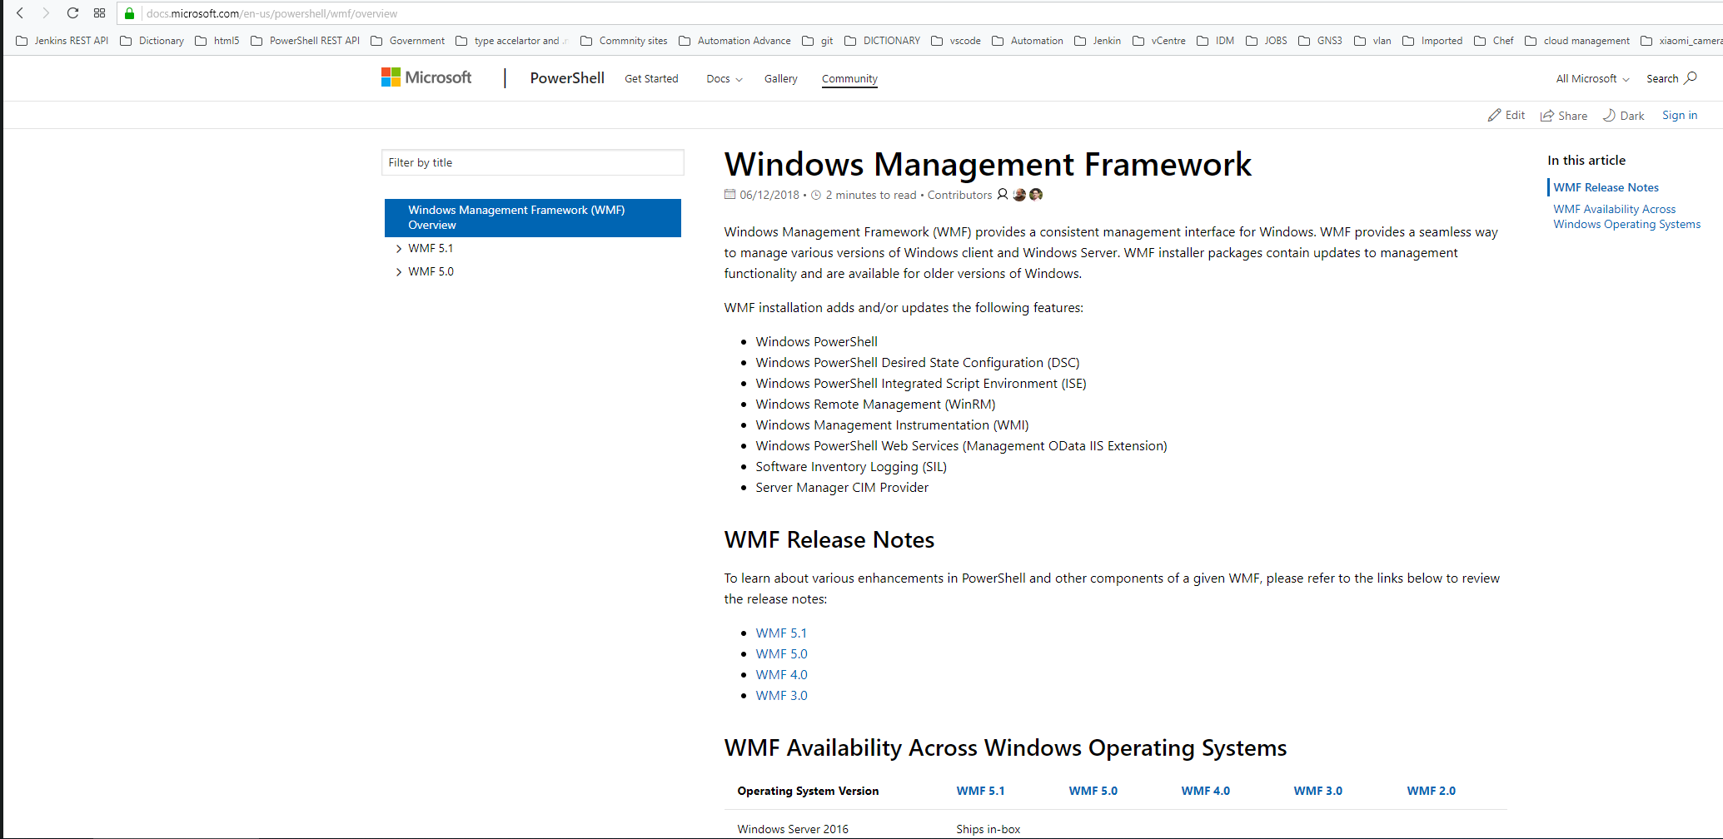

<https://docs.microsoft.com/en-us/powershell/wmf/overview>

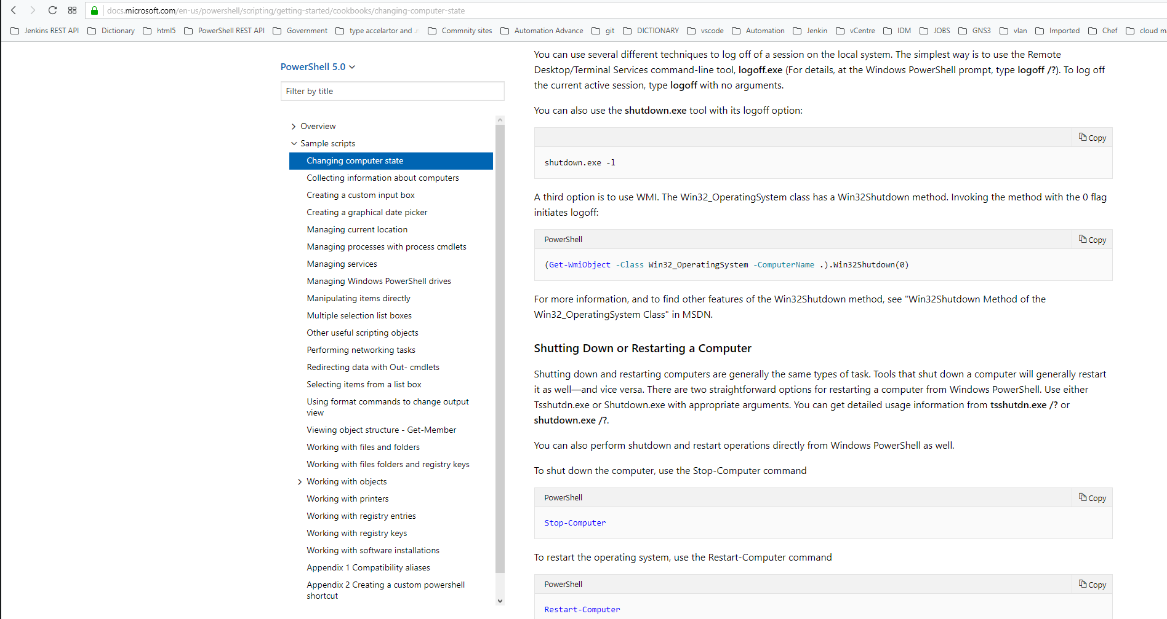

<https://docs.microsoft.com/en-us/powershell/scripting/getting-started/cookbooks/creating-.net-and-com-objects--new-object-?view=powershell-5.0>

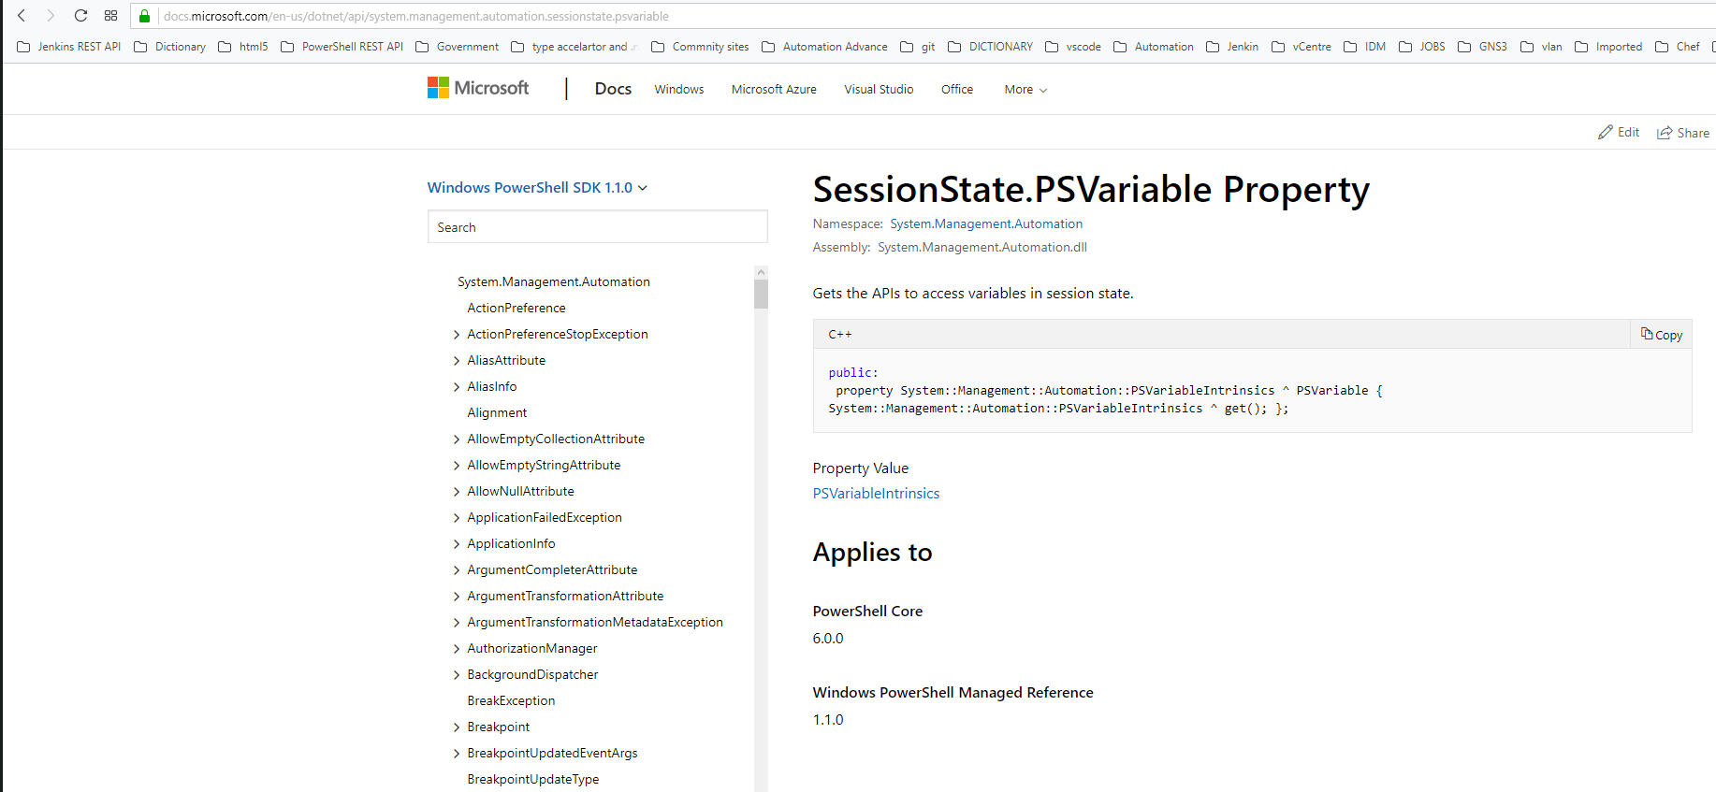

<https://docs.microsoft.com/en-us/dotnet/api/system.management.automation.sessionstate.psvariable?view=powershellsdk-1.1.0>

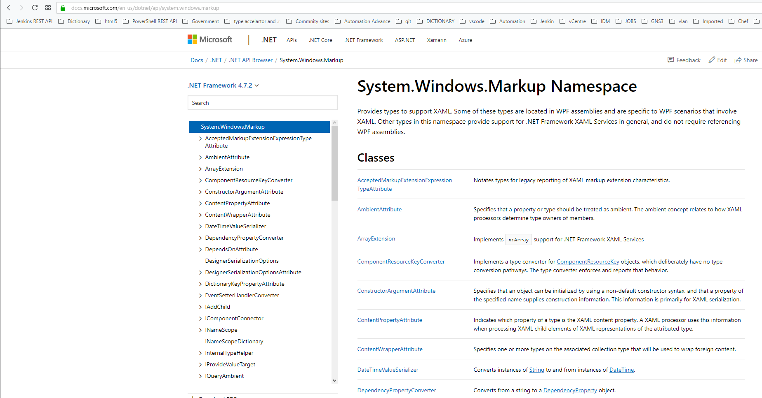

<https://docs.microsoft.com/en-us/dotnet/api/system.math.round?view=netframework-4.7.2#System_Math_Round_System_Double_>

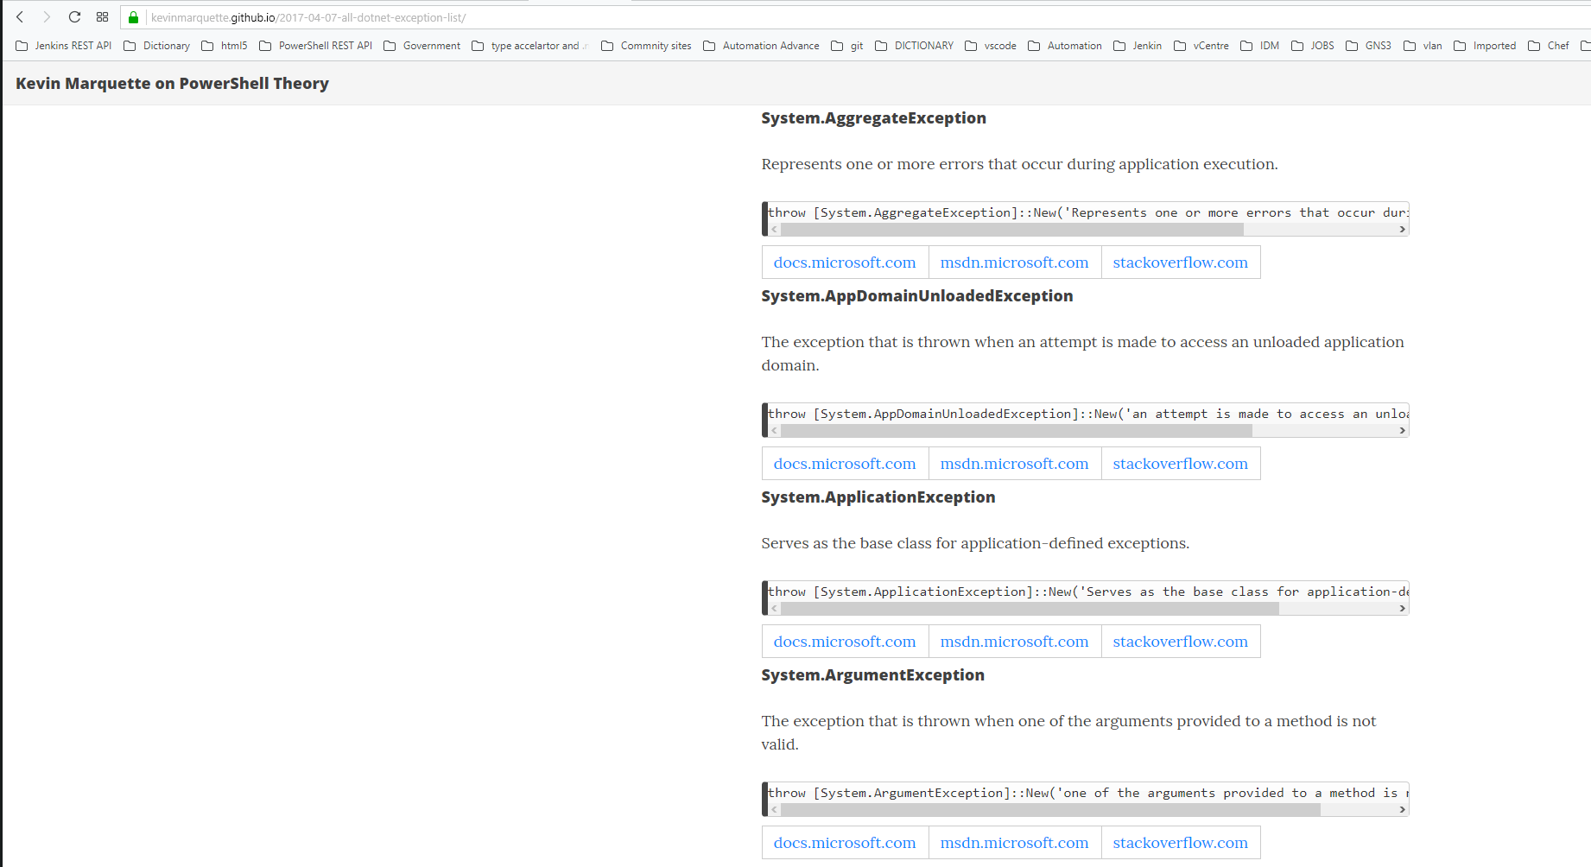

<https://kevinmarquette.github.io/2017-04-07-all-dotnet-exception-list/?utm_source=blog&utm_medium=blog&utm_content=crosspost>

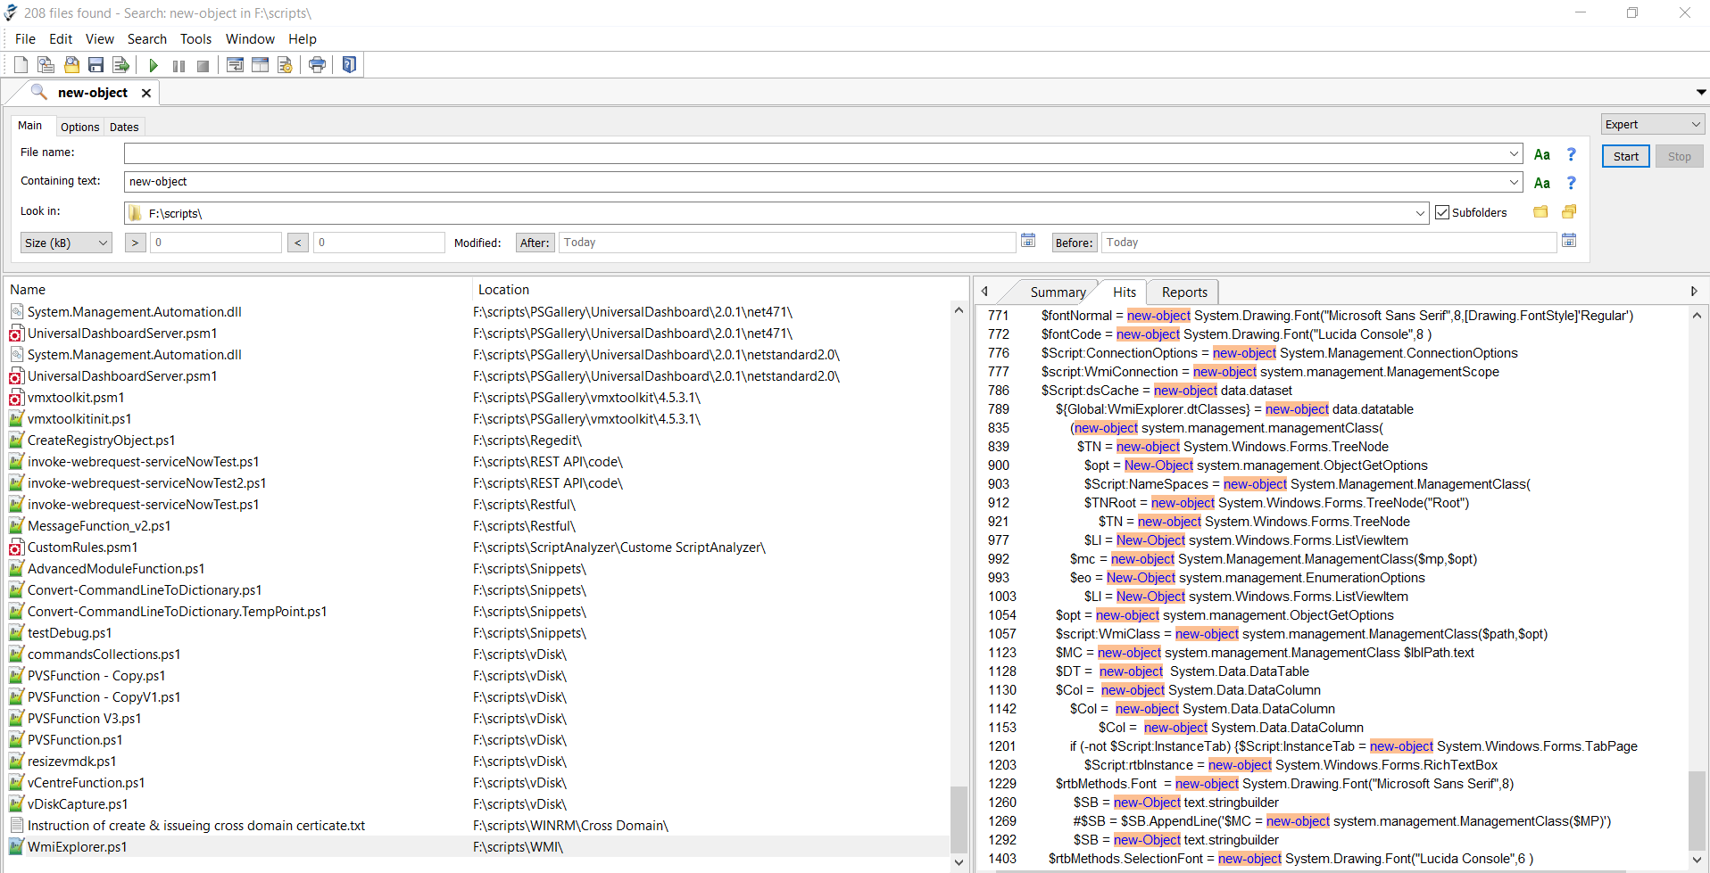

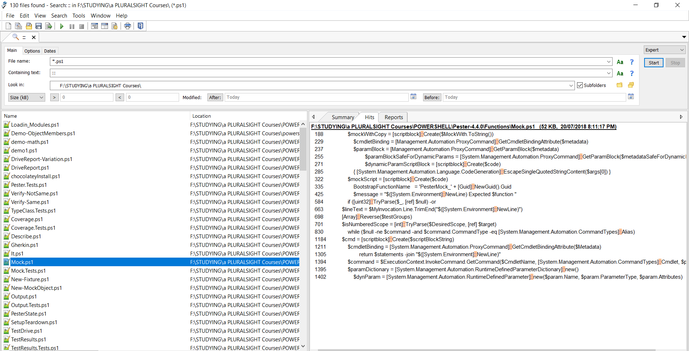

:: can be reference to both .Net and PowerShell SDK

e.g

SDK:

[System.Management.Automation.CommandTypes]::Alias

.NET:

[Array]::Reverse($testGroups)

------

New-object can instantiate to both .Net and PowerShell SDK

e.g

SDK:

$attribute = New-Object Management.Automation.ParameterAttribute

.NET:

$attributeCollection = New-Object Collections.ObjectModel.Collection[Attribute]